### Лабораторная работа № 4

Задание №1.

Настройка SQL*Plus. Необходимо включить режим ECHO и вывести протокол лаб. работы в файл спул файл.

SQL> set echo on

SQL> spool e:\spool.txt

Установить соединение с [базой данных](http://pandia.ru/text/category/bazi_dannih/) под пользователем system/orapass…

SQL> connect system/orapass…

Задание №2

***ДУБЛИКАТ СХЕМЫ SCOTT В Neo4j***

INSERT INTO EMP VALUES (7369, 'SMITH', 'CLERK', 7902, TO_DATE('17-12-1980', 'DD-MM-YYYY'), 800, NULL, 20);

INSERT INTO EMP VALUES (7369, 'SMITH', 'CLERK', 7902, TO_DATE('17-12-1980', 'DD-MM-YYYY'), 800, NULL, 20);

INSERT INTO EMP VALUES (7499, 'ALLEN', 'SALESMAN', 7698, TO_DATE('20-02-1981', 'DD-MM-YYYY'), 1600, 300, 30);

INSERT INTO EMP VALUES (7521, 'WARD', 'SALESMAN', 7698, TO_DATE('22-02-1981', 'DD-MM-YYYY'), 1250, 500, 30);

INSERT INTO EMP VALUES (7566, 'JONES', 'MANAGER', 7839, TO_DATE('2-4-1981', 'DD-MM-YYYY'), 2975, NULL, 20);

INSERT INTO EMP VALUES (7654, 'MARTIN', 'SALESMAN', 7698, TO_DATE('28-9-1981', 'DD-MM-YYYY'), 1250, 1400, 30);

INSERT INTO EMP VALUES (7698, 'BLAKE', 'MANAGER', 7839, TO_DATE('1-5-1981', 'DD-MM-YYYY'), 2850, NULL, 30);

INSERT INTO EMP VALUES (7782, 'CLARK', 'MANAGER', 7839, TO_DATE('9-6-1981', 'DD-MM-YYYY'), 2450, NULL, 10);

INSERT INTO EMP VALUES (7788, 'SCOTT', 'ANALYST', 7566, TO_DATE('09-12-1982', 'DD-MM-YYYY'), 3000, NULL, 20);

INSERT INTO EMP VALUES (7839, 'KING', 'PRESIDENT', NULL, TO_DATE('17-11-1981', 'DD-MM-YYYY'), 5000, NULL, 10);

INSERT INTO EMP VALUES (7844, 'TURNER', 'SALESMAN', 7698, TO_DATE('8-9-1981', 'DD-MM-YYYY'), 1500, 0, 30);

INSERT INTO EMP VALUES (7876, 'ADAMS', 'CLERK', 7788, TO_DATE('12-1-1983', 'DD-MM-YYYY'), 1100, NULL, 20);

INSERT INTO EMP VALUES (7900, 'JAMES', 'CLERK', 7698, TO_DATE('3-12-1981', 'DD-MM-YYYY'), 950, NULL, 30);

INSERT INTO EMP VALUES (7902, 'FORD', 'ANALYST', 7566, TO_DATE('3-12-1981', 'DD-MM-YYYY'), 3000, NULL, 20);

INSERT INTO EMP VALUES (7934, 'MILLER', 'CLERK', 7782, TO_DATE('23-1-1982', 'DD-MM-YYYY'), 1300, NULL, 10);

INSERT INTO EMP VALUES (7934, 'MILLER', 'CLERK', 7782, TO_DATE('23-1-1982', 'DD-MM-YYYY'), 1300, NULL, 10);

Create(SMITH:employees{EMPNO:7369,ENAME:'SMITH',SAL:800, DEPTNO:20})

Create(ALLEN:employees{EMPNO:7499,ENAME:'ALLEN',SAL:1600, DEPTNO:30})

Create(WARD:employees{EMPNO:7521,ENAME:'WARD',SAL:1250, DEPTNO:30})

Create(JONES:employees{EMPNO:7566,ENAME:'JONES',SAL:2975, DEPTNO:20})

Create(MARTIN:employees{EMPNO:7654,ENAME:'MARTIN',SAL:1250, DEPTNO:30})

Create(BLAKE:employees{EMPNO:7698,ENAME:'BLAKE',SAL:2850, DEPTNO:30})

Create(CLARK:employees{EMPNO:7782,ENAME:'CLARK',SAL:2450, DEPTNO:10})

Create(SCOTT:employees{EMPNO:7788,ENAME:'SCOTT',SAL:3000, DEPTNO:20})

Create(KING:employees{EMPNO:7839,ENAME:'KING',SAL:5000, DEPTNO:10})

Create(TURNER:employees{EMPNO:7844,ENAME:'TURNER',SAL:1500, DEPTNO:30})

Create(ADAMS:employees{EMPNO:7876,ENAME:'ADAMS',SAL:1100, DEPTNO:20})

Create(JAMES:employees{EMPNO:7900,ENAME:'JAMES',SAL:950, DEPTNO:30})

Create(FORD:employees{EMPNO:7902,ENAME:'FORD',SAL:3000, DEPTNO:20})

Create(MILLER:employees{EMPNO:7934,ENAME:'MILLER',SAL:1300, DEPTNO:10})

match(n) return n

INSERT INTO DEPT VALUES (10, 'ACCOUNTING', 'NEW YORK');

INSERT INTO DEPT VALUES (20, 'RESEARCH', 'DALLAS');

INSERT INTO DEPT VALUES (30, 'SALES', 'CHICAGO');

INSERT INTO DEPT VALUES (40, 'OPERATIONS', 'BOSTON');

CREATE (D10:departments {DEPNO: 10, LOC: 'NEW YORK'})

CREATE (D20:departments {DEPNO: 20, LOC: 'DALLAS'})

CREATE (D30:departments {DEPNO: 30, LOC: 'CHICAGO'})

CREATE (D40:departments {DEPNO: 40, LOC: 'BOSTON'})

match(n) return n

MATCH (a:employees), (b:departments)

WHERE a.DEPTNO=10 and b.DEPNO=10

CREATE (a)-[: accounting]->(b)

RETURN a,b

MATCH (a:employees), (b:departments)

WHERE a.DEPTNO=20 and b.DEPNO = 20

CREATE (a)-[: research]->(b)

RETURN a,b

MATCH (a:employees), (b:departments)

WHERE a.DEPTNO=30 and b.DEPNO = 30

CREATE (a)-[: sales]->(b)

RETURN a,b

MATCH (a:employees), (b:departments)

WHERE a.DEPTNO=40 and b.DEPNO = 40

CREATE (a)-[: operations]->(b)

RETURN a,b

match(n) return n

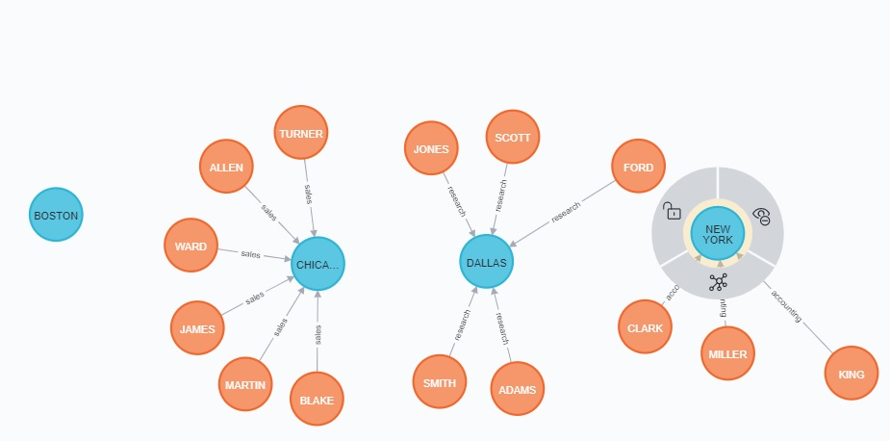

ИЛИ КАК ВАРИАНТ

MATCH (a:employees), (b:departments)

WHERE a.DEPTNO=b.DEPNO

CREATE (a)-[:works]->(b)

RETURN a,b

match(n) return n

**ЗАПРОСЫ**

|  |  |
| --- | --- |
| SQL | Neo4j |
| select * from emp; | match (a:employees) return a |
| select * from dept; | match (a:departments) return a |
| select ename, sal from emp; | MATCH (a:employees)RETURN a.ENAME, a.SAL |
| select ename from emp; | MATCH (a:employees)RETURN a.ENAME |
| select ename from emp  where ename=’smith’; | MATCH (a:employees {ENAME:'SMITH'})  RETURN a |
| WHERE id IN (0, 3, 5) | MATCH (n)  WHERE id(n) IN [0, 3, 5]  RETURN n |
| Select * from r  Where id = 0  Select * from (join a ON b  WHERE a.id = 0 | MATCH ()-[r]->()  WHERE id(r) = 0  RETURN r |
| Select * from r  Where id = 15 | MATCH ()-[r]->()  WHERE id(r) = 15  RETURN r |
| SELECT * FROM (join a ON b  WHERE a.id=b.id | MATCH (a)-[r]-(b)  WHERE id(r) = 0  RETURN a, b |
| ? | MATCH (a)-[r]-(b)  WHERE id(r) = 5  RETURN a, b |
| ?select a.empno, b.depno from emp a, dept b where a.empno = 7369 AND b.depno = 20 | MATCH (a:employees),(b:departments) WHERE a.EMPNO = 7369 AND b.DEPNO = 20 return a,b |
| select a.deptno, b.ename from dept a, emp b | ? MATCH (a:employees),(b:departments)RETURN a.ENAME, b.DEPNO |
| ?select * from emp, dep | MATCH (a:employees), (b:departments) RETURN a, b |
| ? select a.empno, b.depno from emp a, dept b | MATCH (a:employees), (b:departments) RETURN a.ENAME, b.DEPTNO |
| ? select distinct * from emp a, dept b where a.ename = 'SMITH' AND a.deptno=b.deptno; | MATCH (:employees {ENAME: 'SMITH'})--(m:departments)  RETURN m |
| **ВЫБОРКА(SELECT) (σ):**  SELECT * from EMP WHERE SAL>2500; | ? MATCH (a:employees) where a.SAL > 2500 RETURN a |
| **ПРОЕКЦИЯ(PROJECT) (π):**  SELECT DISTINCT ENAME,DEPTNO from EMP;  SELECT DISTINCT DEPTNO, ENAME from EMP;  SELECT DISTINCT DEPTNO from EMP;  **ПРОИЗВЕДЕНИЕ(PRODUCT) (×):**  SELECT * from EMP,DEPT; | ?  MATCH (a:employees) RETURN DISTINCT  a.ENAME, a.DEPTNO  MATCH (a:employees) RETURN DISTINCT  a. DEPTNO, a.ENAME  MATCH (a:employees) RETURN DISTINCT  a. DEPTNO |

|  |
| --- |
|  |

|  |  |
| --- | --- |
| **ОБЪЕДИНЕНИЕ(UNION) (∪):**  SELECT ENAME,DEPTNO from EMP UNION SELECT DEPTNO,DNAME, LOC from DEPT;  SELECT DEPTNO from EMP UNION SELECT DEPTNO from DEPT; | ? MATCH (a:employees) RETURN a.ENAME as ename, a.DEPTNO as deptno  UNION ALL  MATCH (b:departments) RETURN b.DNAME as dname, b.DEPTNO as deptno, b.LOC as loc |
| MATCH (a:employees) RETURN a.DEPTNO as deptno  UNION ALL  MATCH (b:departments) RETURN b.DEPTNO as deptno |
| **ПЕРЕСЕЧЕНИЕ(INTERSECT) (∩):** | ? MATCH (a:employees) RETURN a.DEPTNO as deptno  UNION  MATCH (b:departments) RETURN b.DEPTNO as deptno |
| **СОЕДИНЕНИЕ(JOIN) (∏):**  SELECT * from DEPT, EMP WHERE SAL>3000; | ? MATCH (a:employees), (b:departments) where a.SAL > 3000 RETURN a,b |

https://neo4j.com/docs/cypher-manual/current/clauses/match/#match-introduction